**TRIBHUVAN UNIVERSITY**

**INSTITUTE OF ENGINEERING**

**WRC**

**Department of Electronics and Computer Engineering**



Project Report of Automobile Company

(Project D)

Submitted By: PAS076BEI013(Khem Raj Paneru)

PAS076BEI014(Kritam Pathak)

PAS076BEI015(Manish Chhetri)

PAS076BEI016(Manish Poudel)

Submitted to: Balkrishna Neupane

**ACKNOWLEDGEMENT:**

First and foremost, I would like to thank our Teacher (Balkrishna Neupane sir) who guided us in doing this DBMS MINI PROJECT. He provided us with invaluable advice and helped us in difficult periods. His motivation and help contributed tremendously to the successful completion of the project.

Besides, we would like to thank all the friends who helped us by giving us advice and providing the equipment which we needed.

Without that support we couldn’t have succeeded in completing this project.

At last but not in least, we would like to thank everyone who helped and motivated us to work on this project.

**ABSTRACT:**

With the sole aim to perceive a basic overview of database management system we have been asked to do a project titled “Automobile Database Managing”. The prime goal of this project is to maintain the records of car, their model , sales and other information (inventory ,dealers , price, brands of a car etc.), customer details (name, address, phone, etc) through online portal. The proposed Car Sales System application completely automates the existing system

Automobile inventory system deals with the maintenance of records of the details of each customer who had booked car to buy.

Our team had researched a lot of things about the car buying process and had find out that there are lot of problems while selecting a best car according to customer need and it’s very difficult for a customer to visit every showroom to know about the best deal. So we have designed a system that offers a platform for the customer to know about the car of various brands and their model. Also it helps them to maintain the inventory of the showroom and the customer details in a managed and safe manner.

In this project we have used many technologies like HTML, CSS, REACT, NODE JS and MYSQL.

**PROJECT INTRODUCTION:**

The mini project that we have got to do is of title “Automobile Company”. This project is designed using database management system and different other languages such as HTML, CSS, React and MYSQL.

The main aim of this project is to assist the customers, dealers and sales staffs by making the way of storing data easier and reliable.

The tasks were divided into the group members of this group (Group D) so as to decrease the complexity.

Only the admin can maintain the data remained within the project which allows this project to keep records of all data uniquely and securely.

The customers here are intended to buy the cars while browsing through all the options and looking at the functions. They can buy and easily pay through the webpage which makes them convenient to choose the best one along with the budget they have.

The cars of different brands and of different models are listed here. Each car is identified by VIN (Vehicle Identification Number).

This project stores the data of models, brands and options of the cars along with the individual dealers and customers. The relation of all of these are going to be clear through the ER-Diagram.

The user interface for the customer as well as admin is quite attractive and feels fluid like experience. There is no extra show off i.e. only the things that are need to be interacted are shown.

The admin can add, delete and modify the data of customers, dealers, cars, quantity of product, price of product and the description of the product. And admins can also play with data using the SQL command in admin panel like joining two tables, calculating the average price, highest price of car.

**PROBLEM STATEMENT:**

Although there are lots of vehicle showrooms in the country but still all of them are operating its system manually with the paper which is a time consuming and expensive as it needs lots of manpower. If a customer has to buy a vehicle then s/he needs to visit the showroom. Then the staff there shows the brand they have and its version. If the customer likes the brand then s/he would buy else visits next showroom for trying next brand, which is tedious for both customer and showroom.

If customer likes a particular brand model then currently the vehicle booking system at showrooms are done manually, where the buyers need to get the booking form from dealers then fill in the vehicle booking form by handwriting where s/he should fill up a long form about their details and all other essentials, after that they need to get the approval from the verifier staff, then the customer needs to pay for the vehicle and after the showroom records all the essential details the customer is provided with the vehicle s\he desires. This process will use lots of time, space, paper, money and manpower. This tedious process may take a whole day and is very much inconvenient for the customer. Moreover due to the use of paper database it insidious to extract the customer’s details when needed. As an individual handwriting is different from each other than may be it would be difficult for other to understand and other may misunderstand the writing and it may cause a huge problem later. The booking form that had been submits to dealers need to save and keep on the rack. So that this procedure will need large space to keep the record for further needs .Dealers will also have problem to manage the records accurately, like when the paper is cut out or missing.

**OBJECTIVE:**

The objective of this project is to replace the hardcopy database system into softcopy system where it would be easier and reliable to manage every details of the dealers, cars, customers and transactions of the automobile company in safe way.

**METHODOLOGY:**

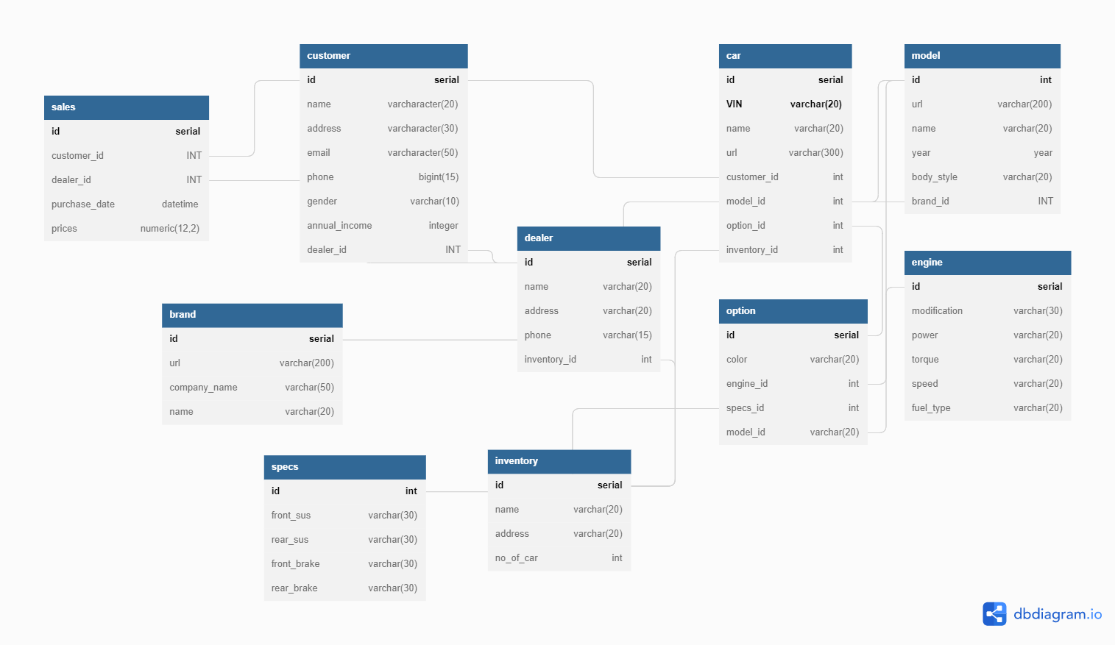

Fig: Database Schema Diagram:

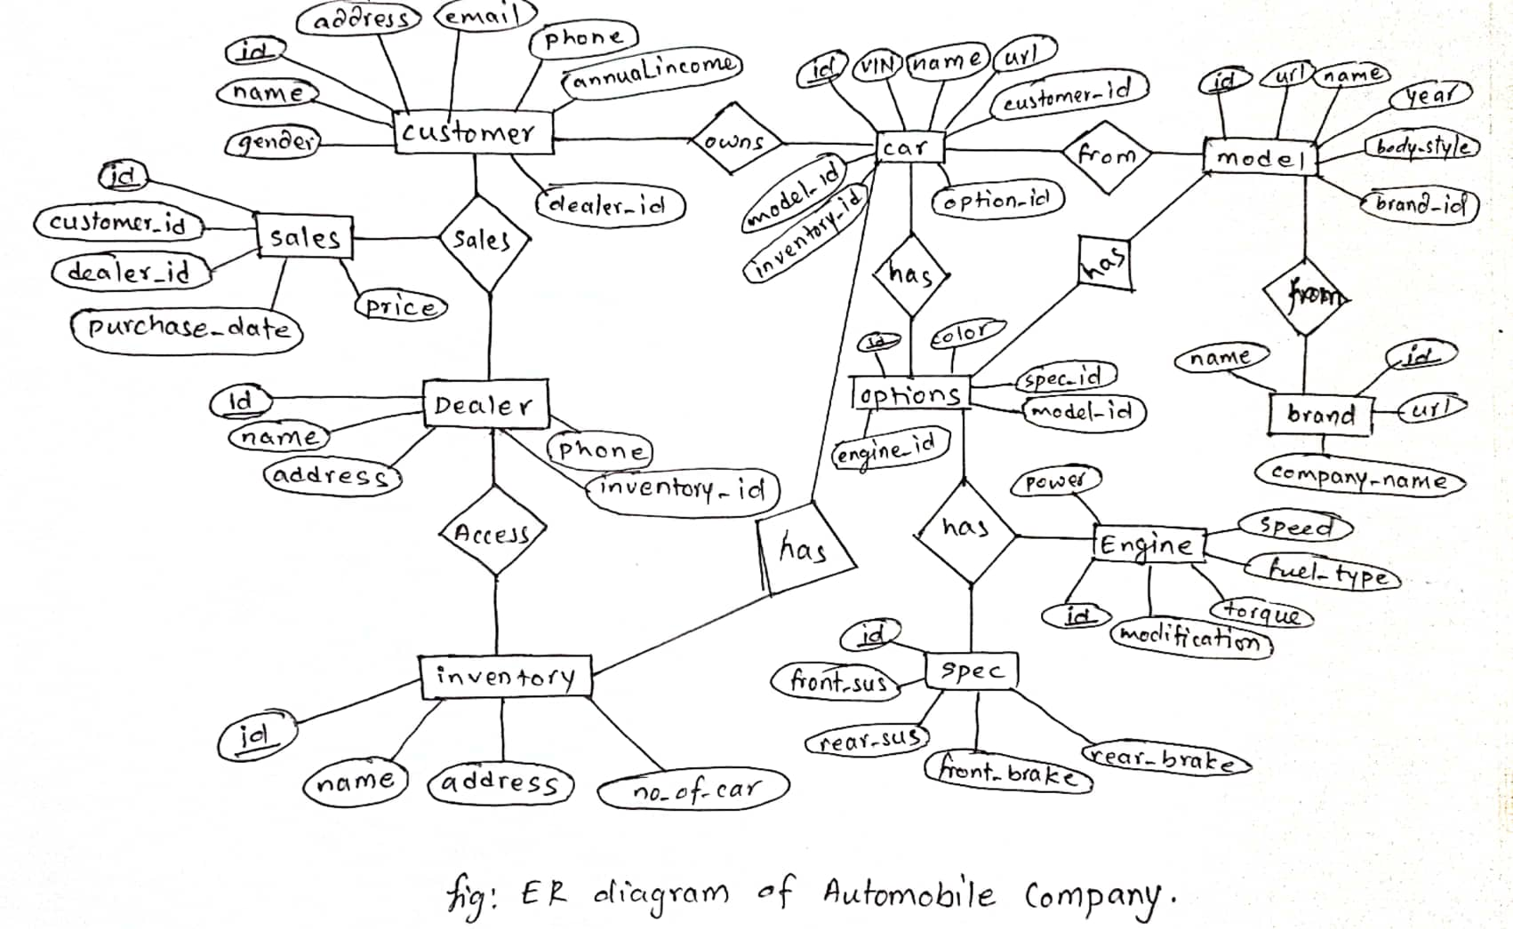

**MYSQL Query:**

CREATEDATABASE Automobile_Company;

USE Automobile_Company;

CREATE TABLE `customer` (

`id` serial PRIMARY KEY AUTO_INCREMENT,

`name` varchar(20),

`address` varchar(30),

`email` varchar(50),

`phone` bigint(15),

`gender` varchar(10),

`annual_income` integer,

`dealer_id` INT

);

CREATE TABLE `sales` (

`id` serial PRIMARY KEY AUTO_INCREMENT,

`customer_id` INT,

`dealer_id` INT,

`purchase_date` datetime,

`prices` numeric(12,2)

);

CREATE TABLE `car` (

`id` serial AUTO_INCREMENT,

`VIN` varchar(20),

`name` varchar(20),

`url` varchar(300),

`customer_id` int,

`model_id` int,

`option_id` int,

`inventory_id` int,

PRIMARY KEY (`id`, `VIN`));

CREATE TABLE `model` (

`id` int PRIMARY KEY AUTO_INCREMENT,

`url` varchar(200),

`name` varchar(20),

`year` year,

`body_style` varchar(20),

`brand_id` INT

);

CREATE TABLE `brand` (

`id` serial PRIMARY KEY AUTO_INCREMENT,

`url` varchar(200),

`company_name` varchar(50),

`name` varchar(20)

);

CREATE TABLE `dealer` (

`id` serial PRIMARY KEY AUTO_INCREMENT,

`name` varchar(20),

`address` varchar(20),

`phone` varchar(15),

`inventory_id` int

);

CREATE TABLE `option` (

`id` serial PRIMARY KEY AUTO_INCREMENT,

`color` varchar(20),

`engine_id` int,

`specs_id` int,

`model_id` varchar(20)

);

CREATE TABLE `engine` (

`id` serial PRIMARY KEY AUTO_INCREMENT,

`modification` varchar(30),

`power` varchar(20),

`torque` varchar(20),

`speed` varchar(20),

`fuel_type` varchar(20)

);

CREATE TABLE `specs` (

`id` int PRIMARY KEY AUTO_INCREMENT,

`front_sus` varchar(30),

`rear_sus` varchar(30),

`front_brake` varchar(30),

`rear_brake` varchar(30)

);

CREATE TABLE `inventory` (

`id` serial PRIMARY KEY AUTO_INCREMENT,

`name` varchar(20),

`address` varchar(20),

`totalCar ` int

);

CREATE TABLE `customer_sales` (

`customer_id` serial NOT NULL,

`sales_customer_id` INT NOT NULL,

PRIMARY KEY (`customer_id`, `sales_customer_id`)

);

--- ***Foreign relationship SQL Query***

ALTER TABLE `customer` ADD FOREIGN KEY (`dealer_id`) REFERENCES `dealer` (`id`);

ALTER TABLE `customer_sales` ADD FOREIGN KEY (`customer_id`) REFERENCES `customer` (`id`);

ALTER TABLE `customer_sales` ADD FOREIGN KEY (`sales_customer_id`) REFERENCES `sales` (`customer_id`);

ALTER TABLE `dealer` ADD FOREIGN KEY (`id`) REFERENCES `sales` (`dealer_id`);

ALTER TABLE `car` ADD FOREIGN KEY (`customer_id`) REFERENCES `customer` (`id`);

ALTER TABLE `car` ADD FOREIGN KEY (`model_id`) REFERENCES `model` (`id`);

ALTER TABLE `option` ADD FOREIGN KEY (`id`) REFERENCES `car` (`option_id`);

ALTER TABLE `car` ADD FOREIGN KEY (`inventory_id`) REFERENCES `inventory` (`id`);

ALTER TABLE `model` ADD FOREIGN KEY (`brand_id`) REFERENCES `brand` (`id`);

ALTER TABLE `inventory` ADD FOREIGN KEY (`id`) REFERENCES `dealer` (`inventory_id`);

ALTER TABLE `option` ADD FOREIGN KEY (`engine_id`) REFERENCES `engine` (`id`);

ALTER TABLE `option` ADD FOREIGN KEY (`specs_id`) REFERENCES `specs` (`id`);

ALTER TABLE `option` ADD FOREIGN KEY (`model_id`) REFERENCES `model` (`id`);

**Some Queries:**

SET foreign_key_checks = 0;

SET foreign_key_checks = 1;

***update***

UPDATE customer SET dealer_id = 1 WHERE id=2;

UPDATE customer SET dealer_id = 2 WHERE id=1;

***Reading the data from table***

select c.name ,b.name,VIN from customer as c join purchase as p on c.id=p.customer_id join car as b on b.id=p.car_id;

select * from model;

select * from car ;

select * from dealer;

select * from engine;

select * from specs;

select * from options;

select * from inventory;

select * from car where model.id=1;

select * from car join model on model.id=car.model_id join options on options.id=car.option_id ;

select * from (options join engine on engine.id=options.engine_id) join specs on specs.id= options.specs_id where options.id=2;

select I.name,address,I.dealer_id from car join inventory as I on car.inventory_id=I.id where car.id=4;

ALTER TABLE `model`

CHANGE COLUMN `name` `name` VARCHAR(20) NULL ,

ADD UNIQUE INDEX `name_UNIQUE` (`name` ASC) VISIBLE;

select inventory_id, count(inventory_id) as totalCar from car group by inventory_id;

ALTER TABLE inventory

ADD COLUMN `totalCar` INT NULL DEFAULT 0 AFTER `address`;

***Delete***

Drop table model;

Drop table brand;

ALTER TABLE `inventory`

DROP FOREIGN KEY `inventory_ibfk_1`;

ALTER TABLE `inventory`

DROP COLUMN `dealer_id`,

DROP INDEX `dealer_id` ;

***Triggering***

create trigger `brand_date_created` before insert

on `brand`

for each row

set new.`date_created` = now();

create trigger `totalCar` before insert

on `inventory`

for each row

set new.`totalCar` = (select count(inventory_id) as totalCar from car ,inventory where inventory_id=new.id

drop trigger brand_date_created;

**RESULT:**

The following are some of the screenshots of the interface of our project:

1. **Brand List page**

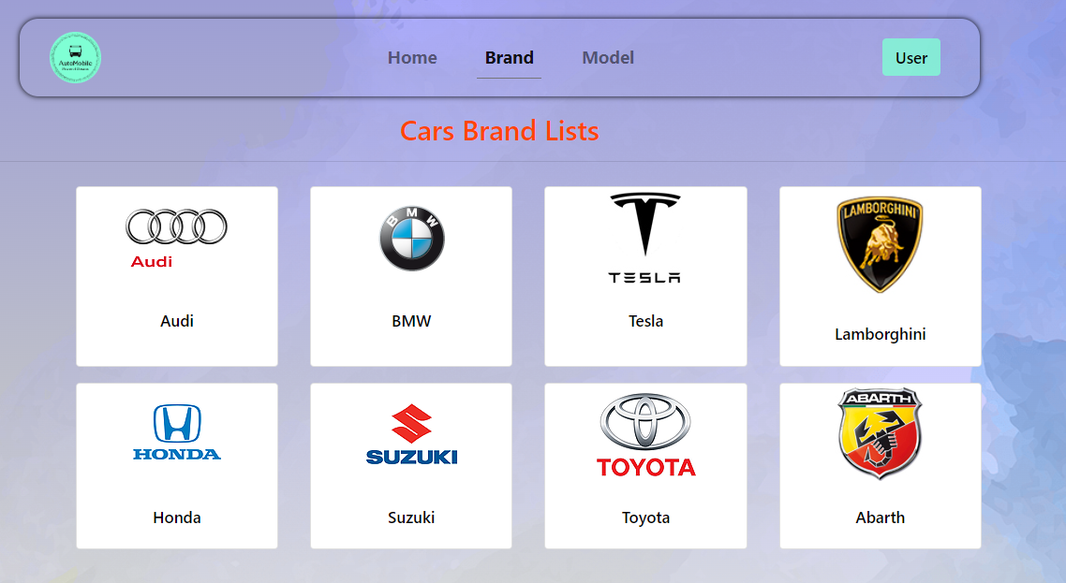

1. **Car List Page**

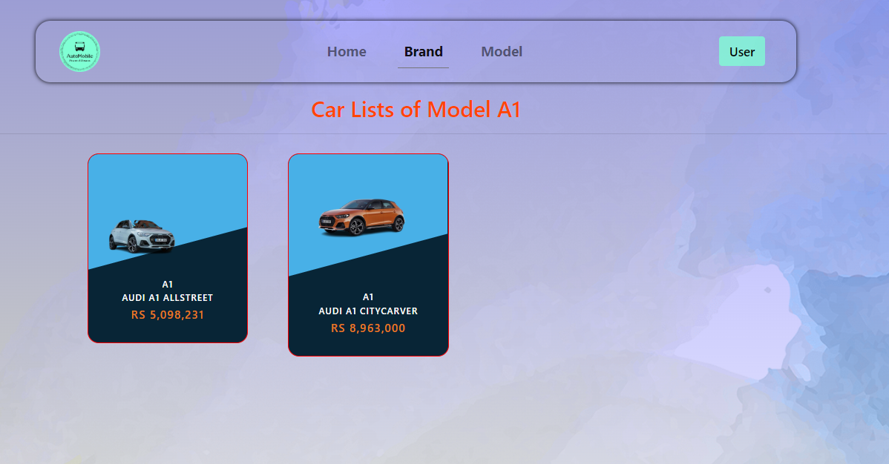

1. **Car Details Page**

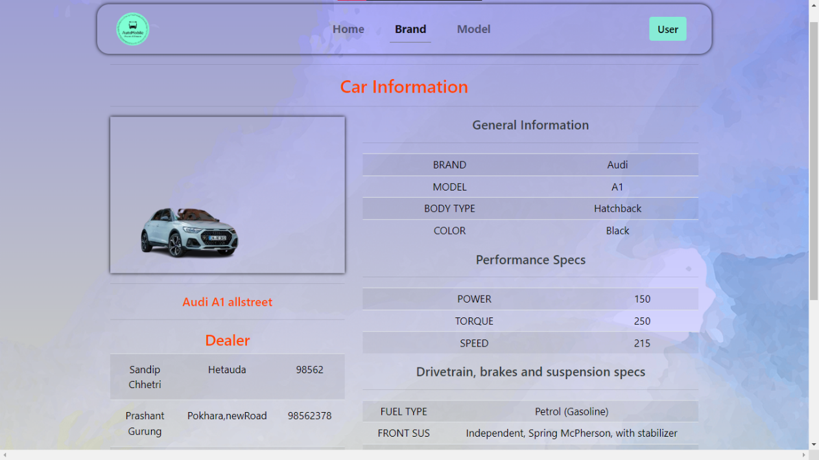

1. **Admin Pages**

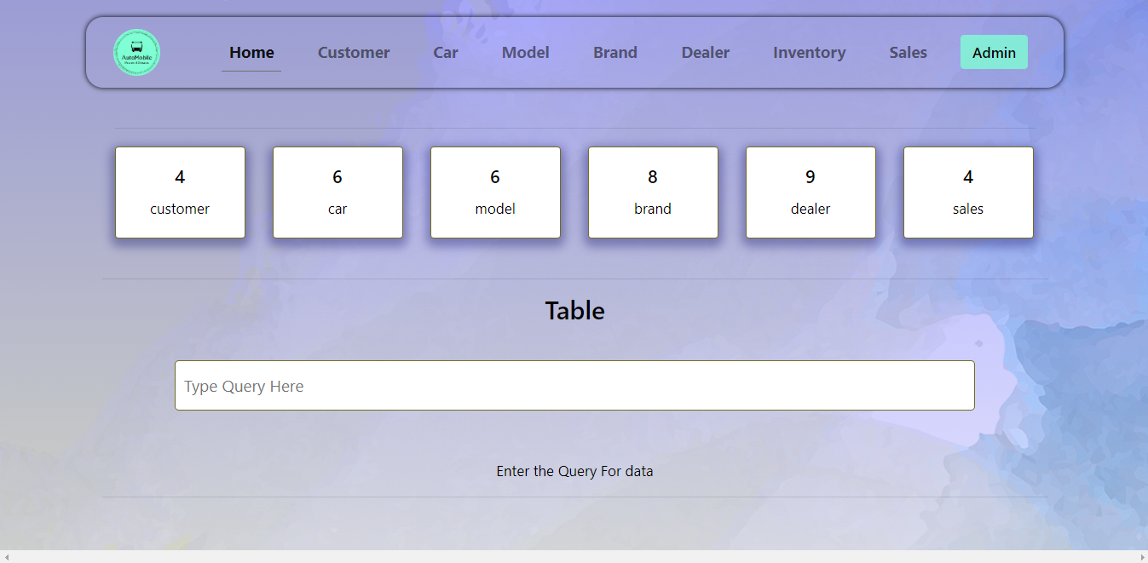

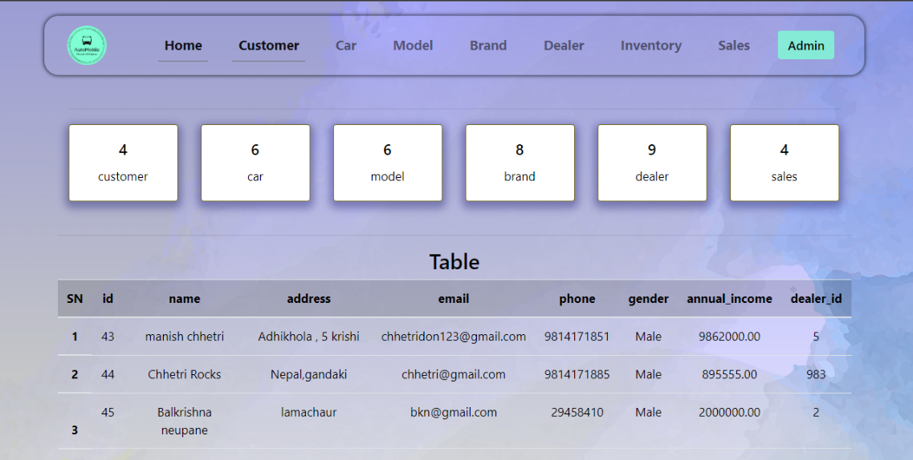

**CONCLUSION:**

To conclude the “automobile company” project, this project is basically a small project to learn about the database management system and implement the concept we learnt in the lab. Through this project we came to learn about basic web development through HTML, CSS and REACT and manage the database through MYSQL. We also learnt how to work as a team and importance of patience under pressure.

Some of the scope we can increase for the betterment and effectiveness of the project are:

1. Logging System for the user. [Authentication, Authorization]

2. Online payment system can be added

3. Data can be protected from being lost or stolen.

4. Can expand this project by adding different features like Available buses of different model and brand, and adding other vehicle.

5. Car comparing table can be added which compares two cars and give the best car option to buy.

The live demo of our project is here in this link: - https://automobilewrc.netlify.app/